EMBEDDED SYSTEM WITH IOT
EXPERIMENT NO. 5

IOT-BASED WATER MONITORING SYSTEM

Name: Raphael S. Nano

Course/Section: CPE162P / C1

Date of Performance: March 29, 2024
Date of Submission: March 29, 2024

Ma'am Cyrel Manlises
Instructor

DISCUSSION

The technologies designed to monitor water quality, quantity, and distribution benefit from the IoT implementation significantly. IoT-based water monitoring systems have the potential to transform the conventional approach to water resource management through the deployment of interconnected devices and sensors. They are crucial in the monitoring of water quality, volume, and distribution in real-time. With that said, an IoT-based water monitoring system was developed with the use of a water level sensor as the main input and LCD as the output, along with a value update in ThingSpeak every minute.

For experiment 5, the objectives are as follows:
1. To demonstrate how an IoT based Water Monitoring System works.
2. To be able apply what you have learned in logic circuits and switching theory, microprocessors, CPE160P, and CPE161P.
3. To be able to apply embedded system with IoT using Arduino kit
4. To be able to use ThingSpeak for the data collection and analysis.

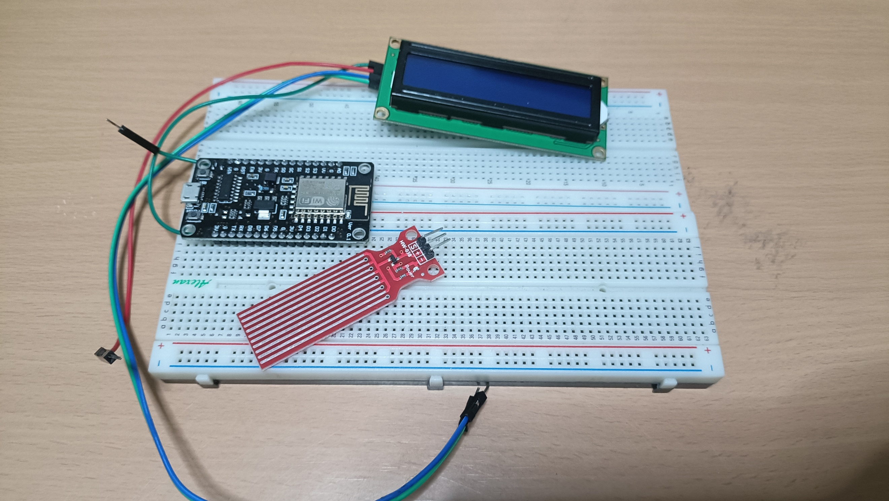
The materials involved in constructing the IoT-based Irrigation System are the ESP8266 WiFi module, HW-038 water level sensor, and liquid crystal display.

Figure 1. Major Components for the Experiment

For the external libraries, ESP8266WiFi.h and ThingSpeak.h are some of the separate libraries included. For the LCD, LiquidCrystal_I2C.h was utilized.
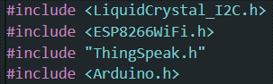

Figure 2. External Libraries Included

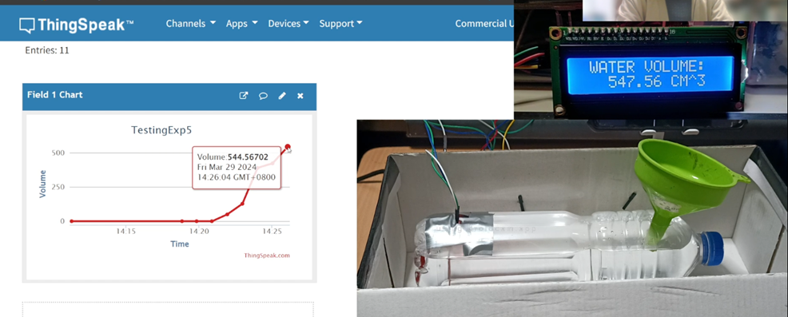
The primary aim of experiment 5 is to detect the flow of water and record the volume of water that flows through the pipe for a given period of time. ThingSpeak will obtain the value of the volume of water within the pipe that is represented by the water bottle every minute.

Figure 3. Sample Output of Experiment 4

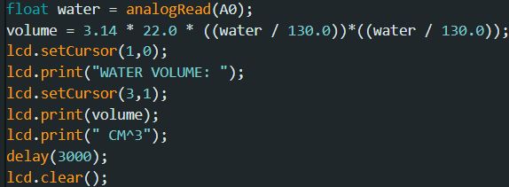
The main components of this experiment are the identifying of the water level and the output of the volume in the LCD. For the water level, the signal pin for the water level sensor is simply triggered and with analogRead, the value of the sensor will be obtained. For the volume, on the other hand, the volume of the water is first computed by assuming that the water bottle is a right cylinder, which is $πr^{2}h$. The height of the bottle is 22 centimeters, whereas the water level sensor is 4 centimeters. The maximum value of the sensor is 520. So, each centimeter would be 130 in analog value, hence the division factor. The volume computed would then be displayed in the LCD using the lcd.print() function.

Figure 4. Main Functions of the System

The same code was utilized in establishing the Wi-Fi connection. It provides information to the user via the Serial Monitor, indicating the status of the connection attempt.
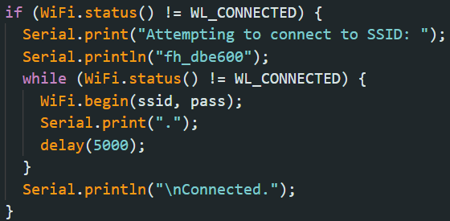

Figure 5. WiFi Function

ThingSpeak updates its fields every 60 seconds or one minute. In this situation, only one field is being displayed, which is the volume of water.
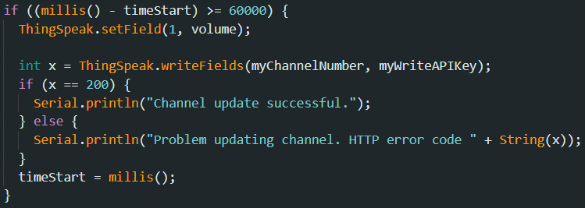

Figure 6. Thingspeak Function

RESULTS
The IoT-based Water Monitoring System was tested for four conditions: (1) No water, (2) Little water, (3) Mid-level water, and (4) High or Maximum level of water. For no water, the water volume is computed to be at 0.69 cubic centimeters. As to why it has little water, the water level sensor is quite wet. Moreover, the ThingSpeak accurately outputs the water volume displayed in the LCD.
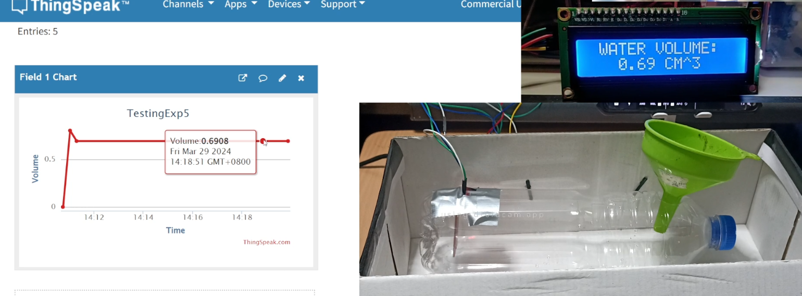

Figure 7. No Water

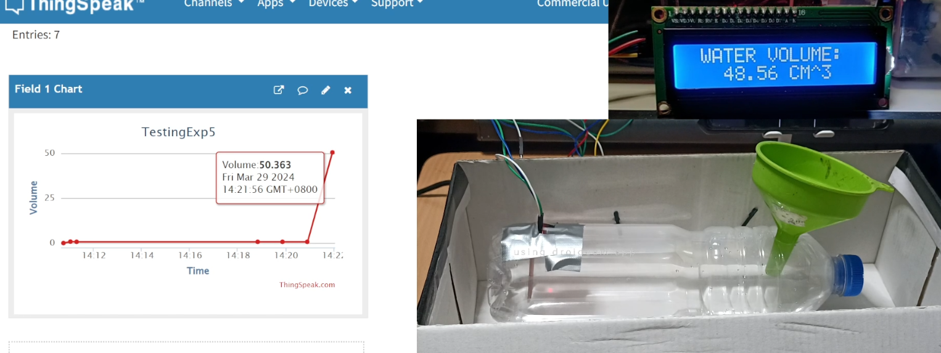
The next part is when the water touches until the lower part of the sensor. The value was detected to be ranging from 48 to 50 cubic centimeters. This is accurate, considering that the bottle is quite large, the water level sensor covers its diameter, and is 22 centimeters in height.

Figure 8. Low Level

For mid-level, the value was identified, ranging from 120 to 150 cubic centimeters. The value in the LCD is different compared to the value in ThingSpeak at this time because the LCD updates every 3 seconds, whereas the ThingSpeak updates every 1 minute.
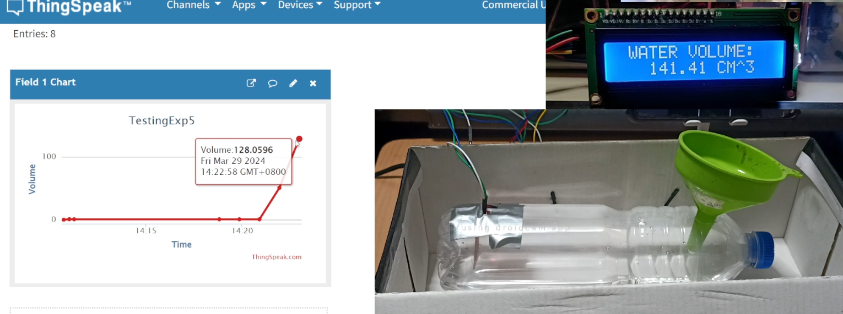

Figure 9. Mid Level
Lastly, at the high or maximum level, the value is approximately at 550 cubic centimeters. Hence, the analog value was accurately identified and the volume was computed using the formula mentioned above.
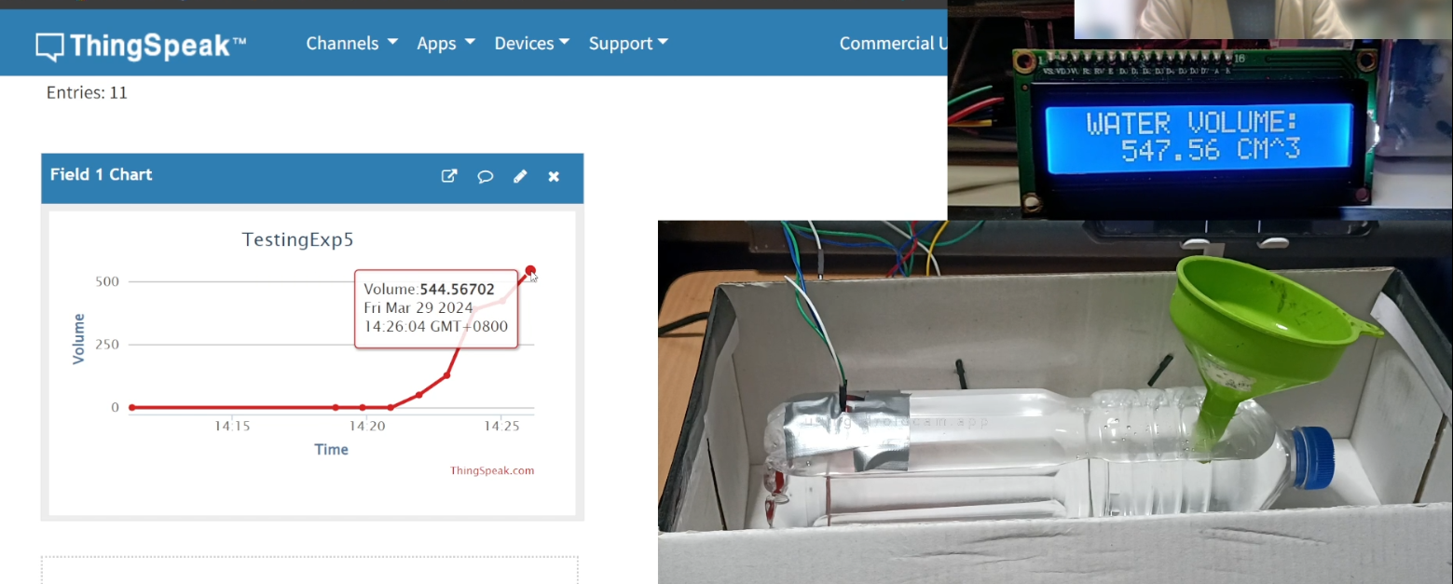

Figure 10. High / Max Level

CONCLUSION
Finally, the IoT-based Water Monitoring System employs the analogRead() and lcd.print() functions to read the water level, compute the volume, and display the volume of the water on the LCD every three seconds. ThingSpeak updates every minute, displaying the volume of water at that precise instant. To achieve the second objective, The CPE160P and CPE161P courses were specifically implemented by connecting the ESP8266 to ThingSpeak via Arduino IDE codes and running the LCD and analog programs. The ThingSpeak efficiently displays the volume of water every minute, which was performed using the writeFields() function. As a result, the IoT-based Water Monitoring System was successfully created, with precise water level sensor readings and clear LCD and ThingSpeak outputs.

